My
Irish Heritage
Coloring Book

This book belongs to: ___________________________________
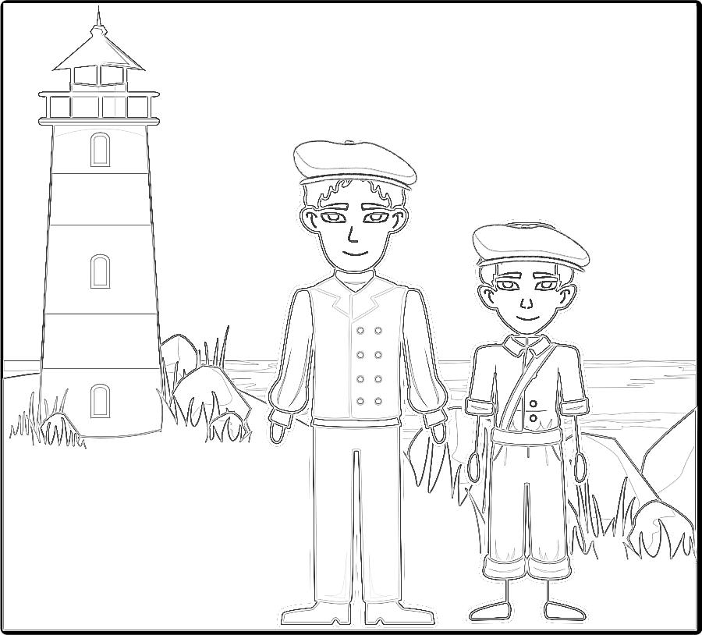
Image created with StoryBoardThat.com
Ireland is sometimes called the Emerald Isle because of the green rolling hills. Where the countryside meets the sea, you’ll find lighthouses guiding ships to port.
These boys are wearing traditional Irish flat caps made of woolen tweed. They were first worn in Ireland in the 16th century. They are sometimes called Donegal caps because County Donegal in Ireland has been manufacturing tweed for centuries.
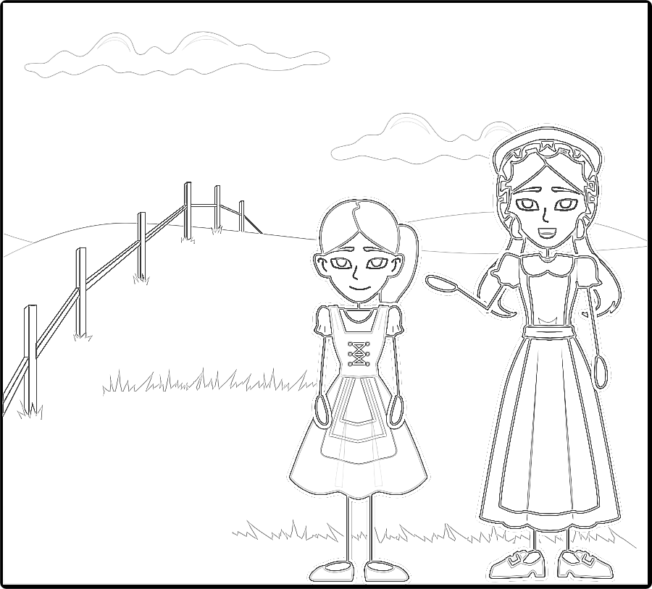
Image created with StoryBoardThat.com

Many Irish boys and girls were taught how to dance in the 1700s by travelling dance masters. Today, many people wear traditional Irish clothing to perform Irish step dances.
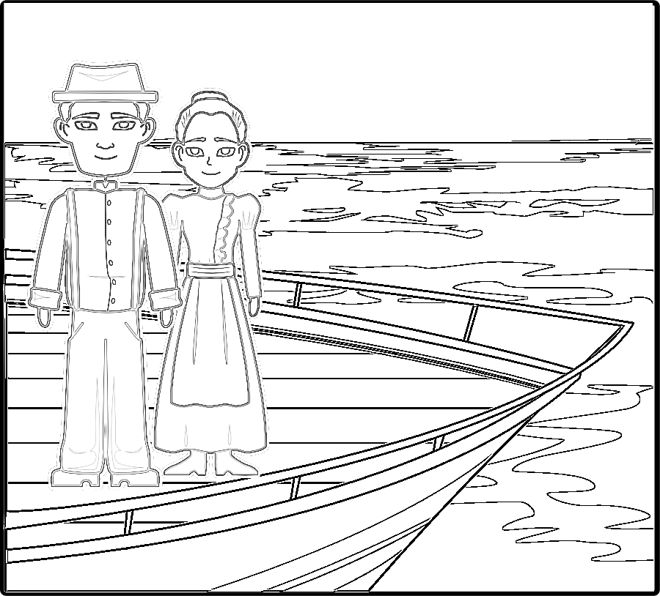
Image created with StoryBoardThat.com

From 1830-1940, over 4 million people left Ireland and sailed across the Atlantic Ocean to the United States. They brought their traditions and love for Ireland with them. Now millions of Americans celebrate Irish culture on Saint Patrick’s Day, March 17th.

The Irish Flag

Green White Orange

The Irish flag is sometimes called the “Irish Tricolor.” Color the flag green on the left and orange on the right. The middle is white.

Green represents the Gaelic leaders of Ireland. Orange represents the Irish people who followed King William of Orange who ruled England, Ireland and Scotland from 1689 - 1702. White represents the hope for peace between the two.

Map of the British Isles
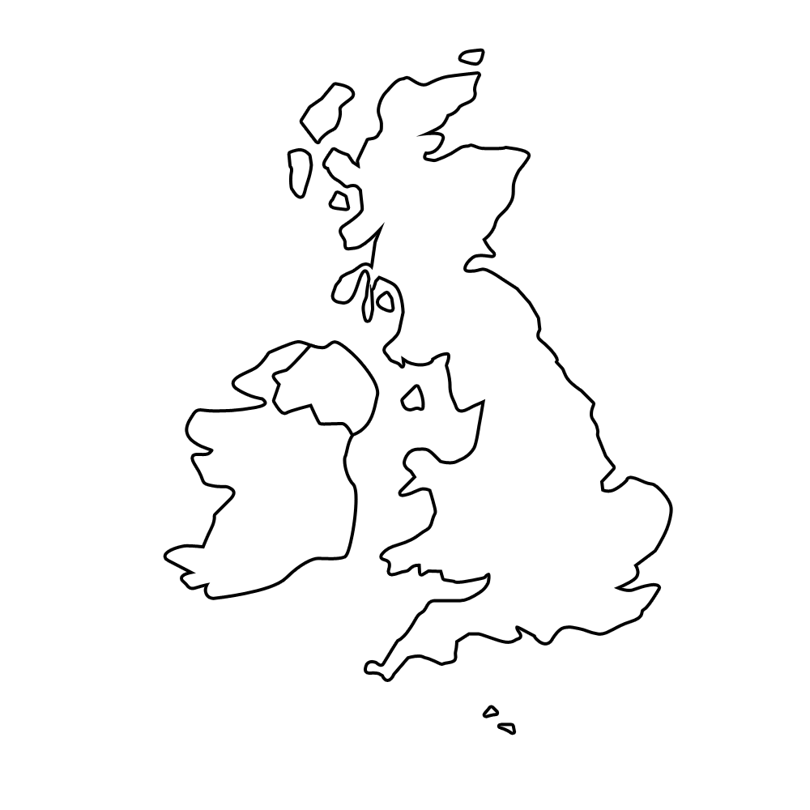
North Atlantic Ocean
North Sea
English Channel
Celtic Sea
United Kingdom
Ireland
Irish Sea
2
2
2
2
2
2
1
1: Green - Ireland
2: Red - United Kingdom
(The United Kingdom includes the island of Great Britain and Northern Ireland and many smaller islands)

My Irish Ancestor

Name:
Born:
Died:

