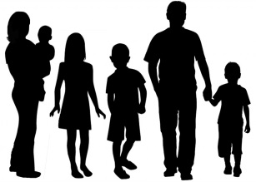
Family Traits
Fill in this family genetic trait chart by starting with yourself. Write your name, and answer yes (Y) or no (N) to each trait – Y if you have it, N if you don’t. These traits are “inherited,” meaning you probably share the same traits with one of your parents or grandparents. Interview your siblings, parents, grandparents, or other relatives to see which traits you share.
Name | Hitchhiker’s thumb | Freckles | Cheek dimples | Attached Earlobes | Tongue roll | Long second toe

FamilyLocket.com
Dominant or Recessive?
You inherited half of your DNA from your mother and half from your father. (But did you know you don’t inherit 25% from each grandparent? It could be that you get 30% from your mom’s mom and 20% from your mom’s dad). Inside your DNA are y our genes. Genes determine your traits. Some genes determine eye color and some determine if you’ll have freckles. You inherited two genes for each trait, one from each parent. Some genes are dominant over the other genes. For example, the ‘freckles gene’ is dominant, and the ‘no freckles’ gene is recessive. If you get one of each of these genes, the freckles gene is dominant and you’ll have freckles. Here’s a chart showing which genes are dominant and recessive for your chart.

Hitchhiker’s thumb | Straight thumb dominant, hitch-hiker thumb recessive
Freckles | Freckles dominant, no freckles recessive
Cheek dimples | Dimples dominant, no dimples recessive
Attached Earlobes | Free lobe dominant, attached recessive
Tongue roll | Roller dominant, nonroller recessive
Long second toe | Long second toe dominant, shorter second toe recessive

