an Heirloom in my family

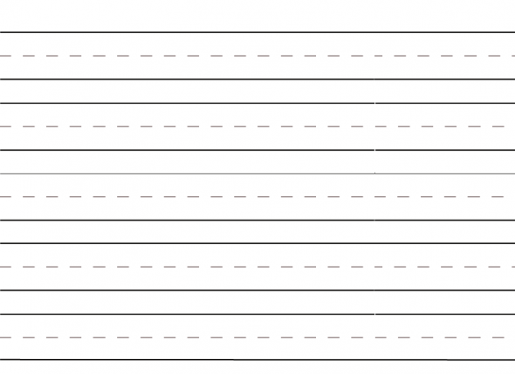

**This heirloom is**