Mission Impossible!
x

Mission Impossible!
x

Puzzilla.org

Mission Impossible!
x

Census Records
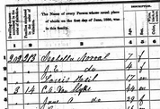

Mission Impossible!
x

Descendancy Tree on FamilySearch.org

Mission Impossible!
x

Landscape Tree on FamilySearch.org

Mission Impossible!
x

Memories on FamilySearch.org

