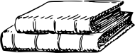
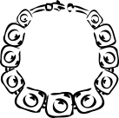
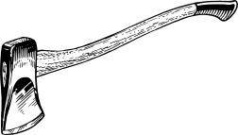
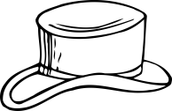
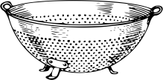
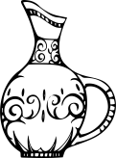
Heirloom Hunt
An heirloom is an item passed down through generations of family members. It could be a toy from your parents’ childhood, a quilt from your grandmother, your grandpa’s army uniform, or a really old photograph of your great-great-grandparents! Use the clues below to search for heirlooms. Talk to your parents and grandparents to see what heirlooms are hiding at your house and their house. You might be surprised by how old some of the items are that you find, and the stories behind them!
Clue | Item and Description  (Ring that Grandma’s dad gave her when she was a little girl - turquoise and silver, size 6, inscription says “pumpkin”) | Who first owned it?  (dad, grandma, great-uncle, great-great-grandmother, etc.) | Where is it?  (Grandma Dyer’s house on the piano, Dad’s closet in a box, etc.)
Keeps you warm
Can play with it
Can be worn
From the kitchen
In the toolshed
Hiding in the closet
Baby item
Reading material
Decoration
Fancy
In a scrapbook
Heirloom Hunt
An heirloom is an item passed down through generations of family members. It could be a toy from your parents’ childhood, a quilt from your grandmother, your grandpa’s army uniform, or a really old photograph of your great-great-grandparents! Talk to your parents and grandparents to see what heirlooms are hiding at your house and their house. You might be surprised by how old some of the items are that you find, and the stories behind them!
Item and Description  (Ring that Grandma’s dad gave her when she was a little girl. Turquoise and silver) | Who first owned it?  (dad, grandma, great-uncle, great-great-grandmother, etc.) | Where is it?  (Grandma Dyer’s house on the piano, Dad’s closet in a box, etc.)

