Super Hero Dad

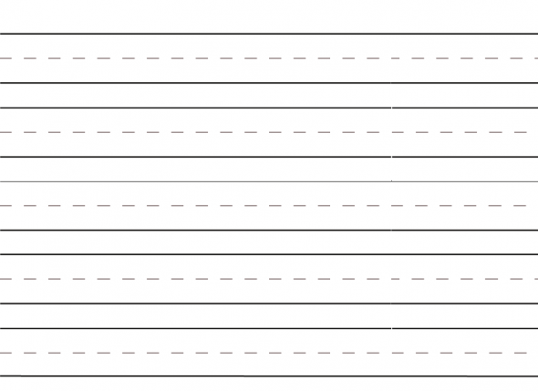

My dad is a super because

I can be like my dad when I

