Discovering Your Roots
Basic Record Types and Strategies

Why Research Family History?
You can find extraordinary things about ordinary people.

How to Begin
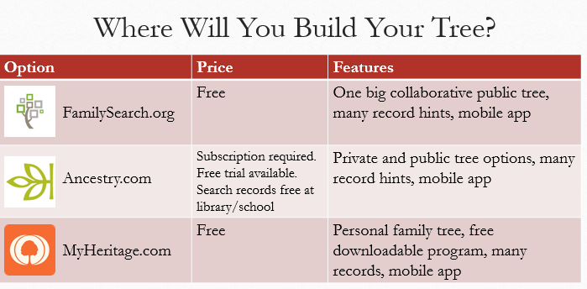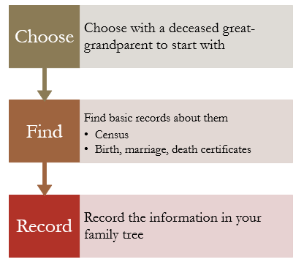

How to Know if Information is Accurate
Primary information and original documents are best.

Information
- *Primary: eyewitness account*
- Secondary: heard from someone else
- Unknown: don’t know the informant

Source
- *Original: first record of an event*
  - Birth, marriage, death records
  - Cemetery records
  - Census records
  - Military records

- Derivative: index, transcription; usually created by a genealogy website, company, historical society, library.
  - Database of births or deaths online
  - Social security death index
  - Census transcriptions

- Authored: original work; usually created by an individual – author, researcher
  - Family trees published online
  - Family history books
  - Biographies
  - Reports

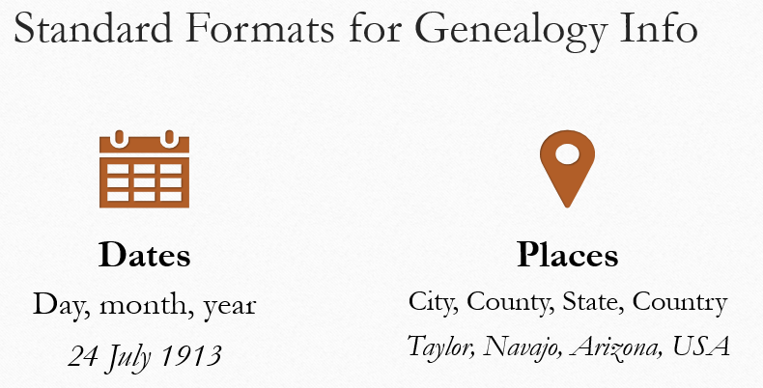
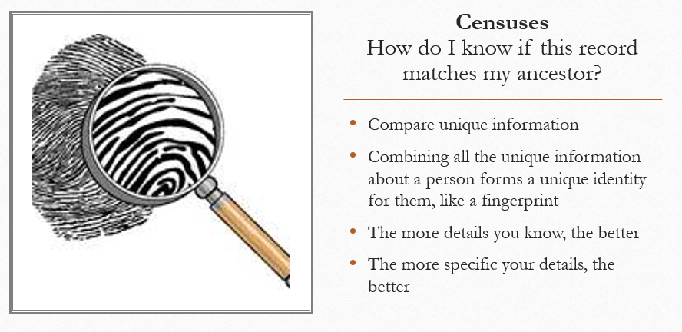

Learn to Research
FamilySearch Wiki
- Encyclopedia for family history research
- https://www.familysearch.org/wiki/en/Main_Page
- Look up places (Ireland, New York, etc.) for links to record collections and how to research there
- Look up record types (newspapers, census records, military research, etc.) to learn how to find them

